BMC Robert Quinn
Officer In Charge
US Coast Guard
ANT Puerto Rico

Re: Teague Bay shallow wreck, St. Croix USVI
Teague Bay is home to the St. Croix Yacht Club, and an active area for boat transit, sailing lessons and pleasure cruising. I, as a member of the St. Croix Yacht Club, write in order to request that the US Coast Guard consider marking a wreck in the Bay with a Federal Aid to Navigation.
A shallow shipwreck in Teague Bay, St Croix, USVI exists at N17° 45.380' W64° 36.321'/17.756333, -64.605350. The wreck is marked on NOAA nautical charts with ED (existence doubtful) (see Figure 1).
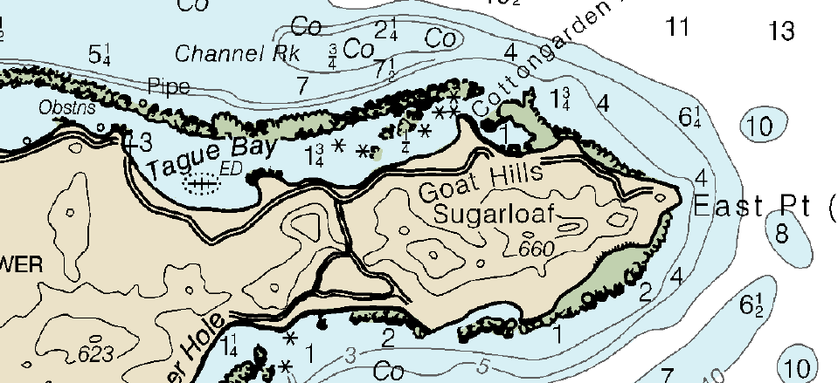
Figure 1 NOAA Nautical Chart of St. Croix's East End with Tague Bay and wreck marked ED
However, the wreck’s existence and location can be confirmed to the west of the mooring field. The outline of the boat can be seen in aerial imagery (Figure 2). The top of the boat is less than a foot from the water’s surface (see Figure 3). The age of this vessel, date of sinking and original owner are unknown. Given the time elapsed, the owner has not been held accountable and is no longer identifiable. However, the shallow nature of the wreck presents a continuing hazard to boating activity in the bay.
Over the years, citizens have, at their own expense, marked this wreck with a simple float, but I believe a permanent marker would serve the navigating public on a more consistent basis.
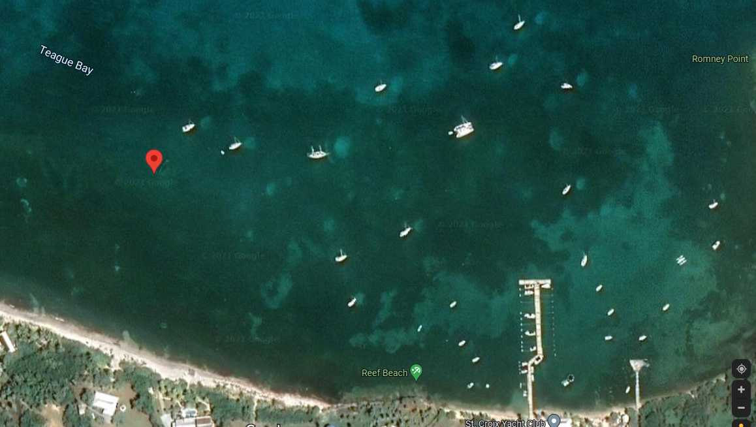
Figure 2 Aerial imagery of Teague Bay. Note proximity of wreck (marked with pin) to active mooring field.
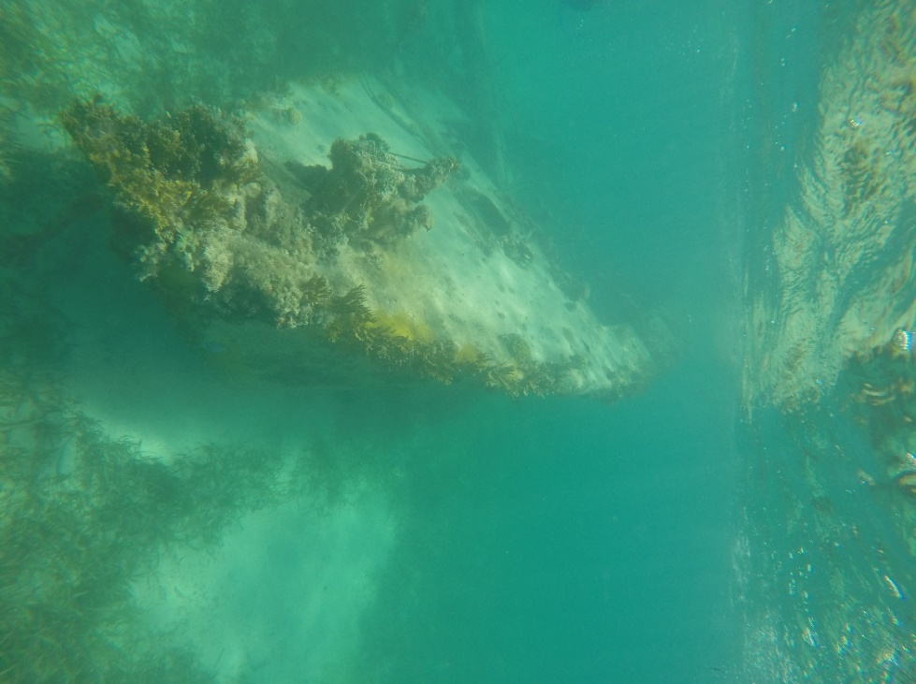
Figure 3 View of the shallow wreck in Teague Bay with water surface

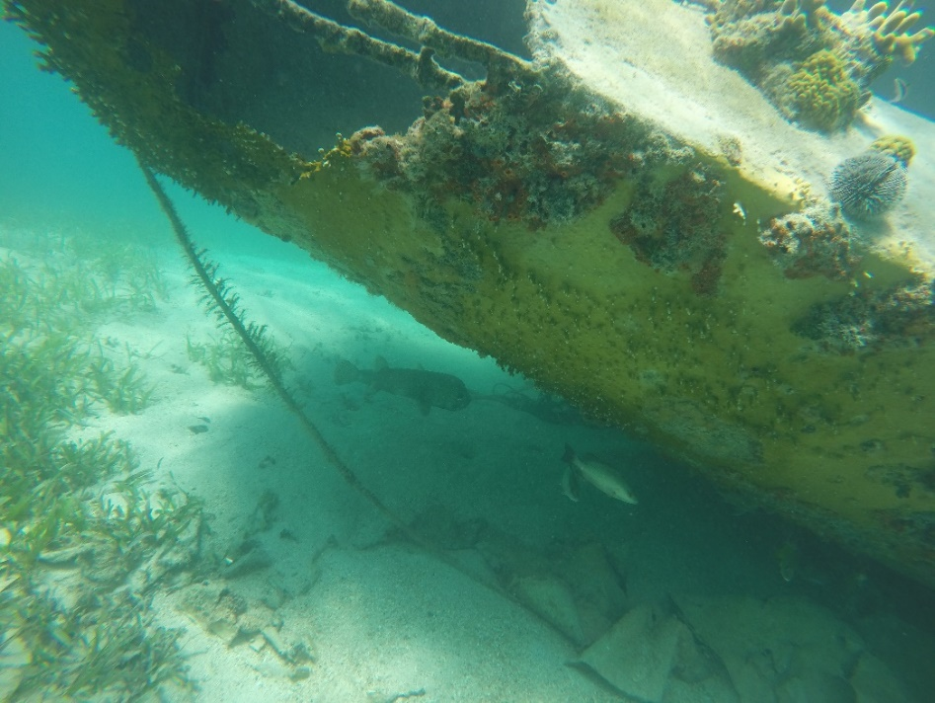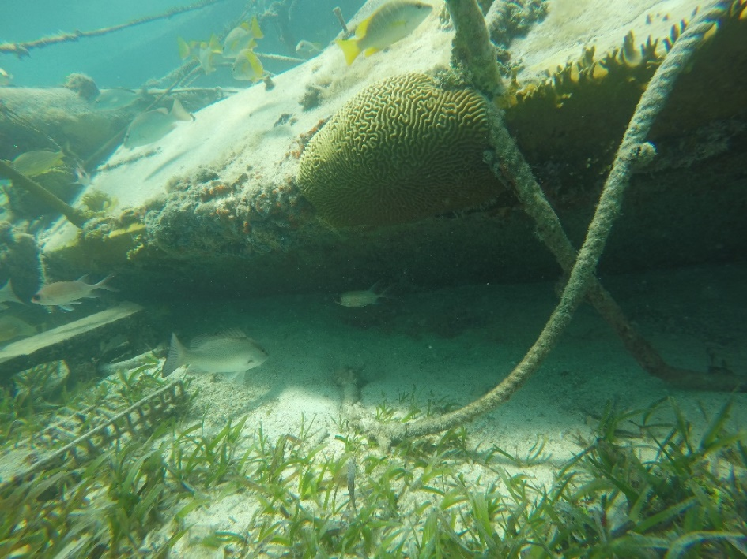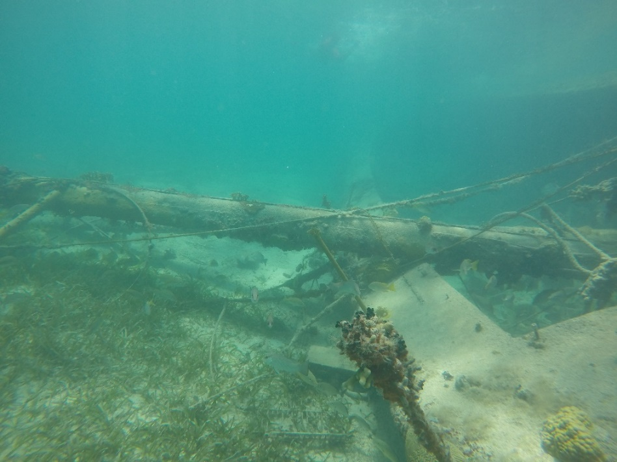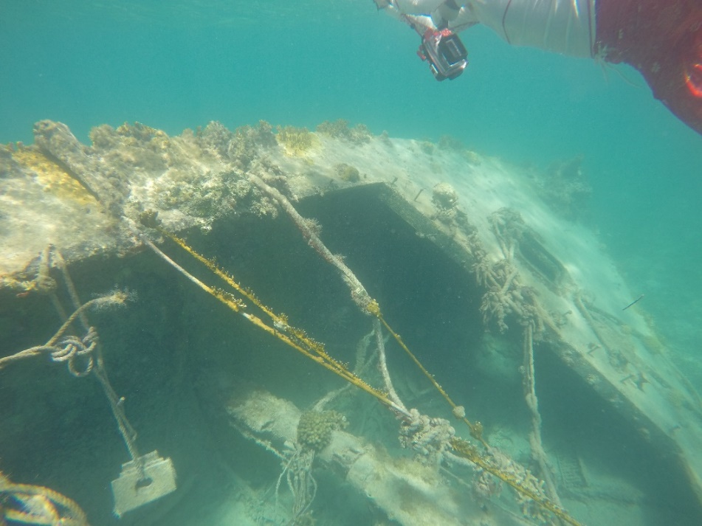
Additional underwater photos of the wreck

